College DIY Projects
Are you looking for some great new ways to
spice up your college dorm room?

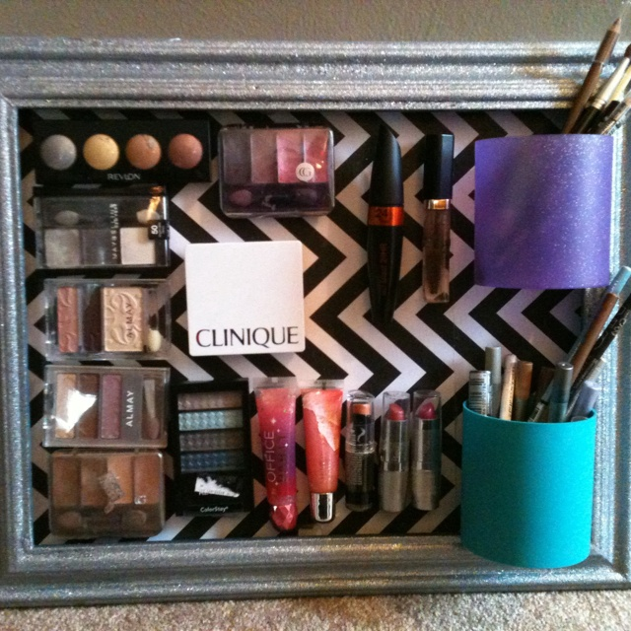

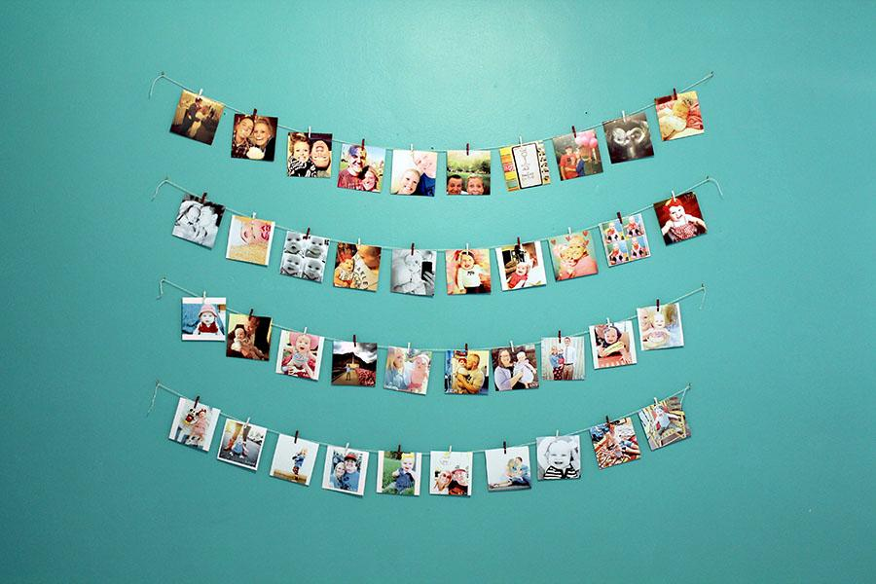

For dorm room Ideas and step by step processes go to my website at:
sammylindeman.weebly.com

